**JONATHAN EMMANUEL PALACIOS GOMEZ**

Python Course:

Day 1

Exercise 1 - Printing

Exercise 2 - Debugging Practice

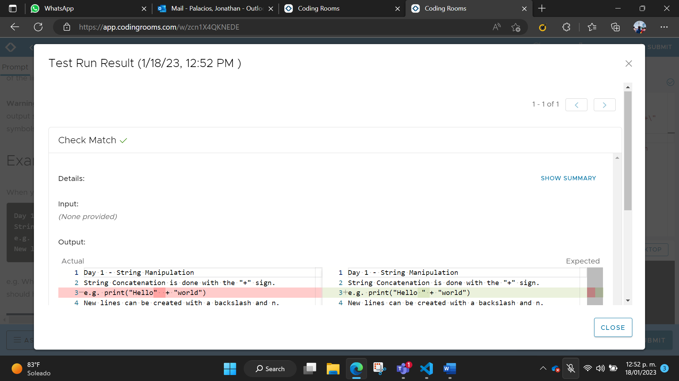

Exercise 3 - Input Function

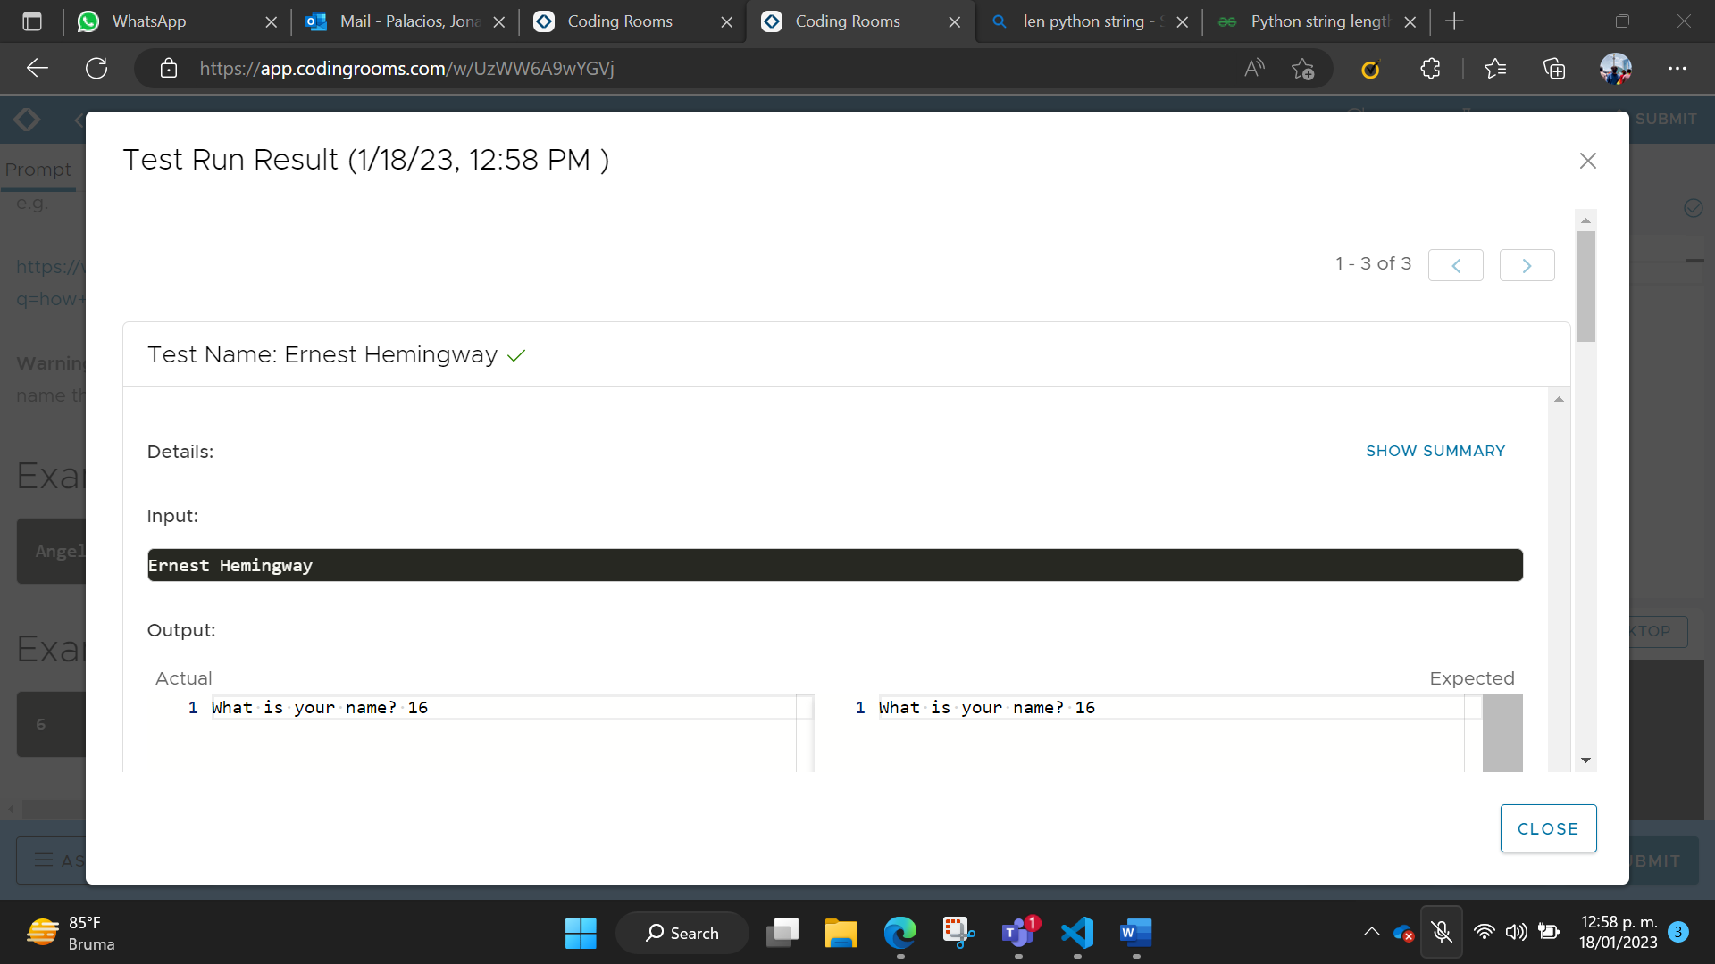

Exercise 4 - Variables

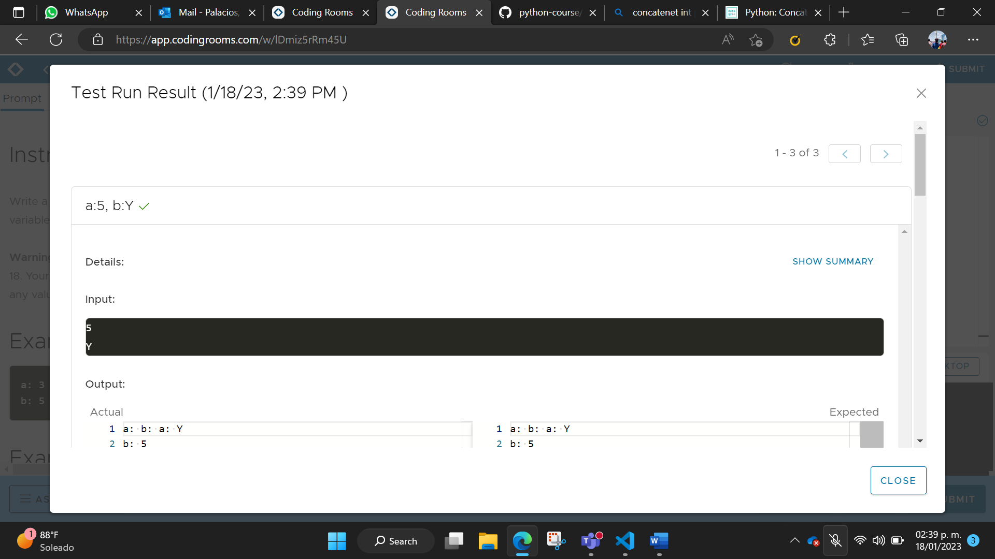

Day 1 Project: Band Name Generator

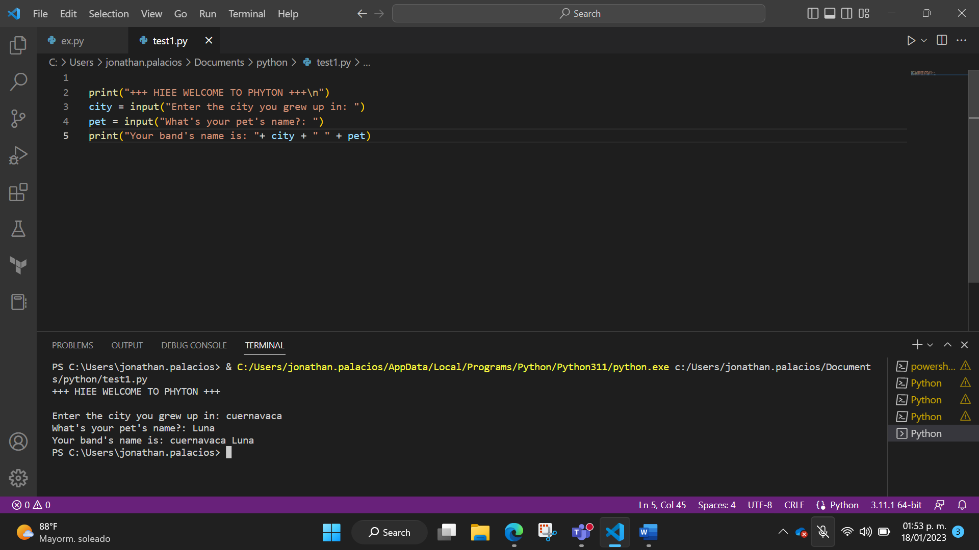

Exercise 5 - Data Types

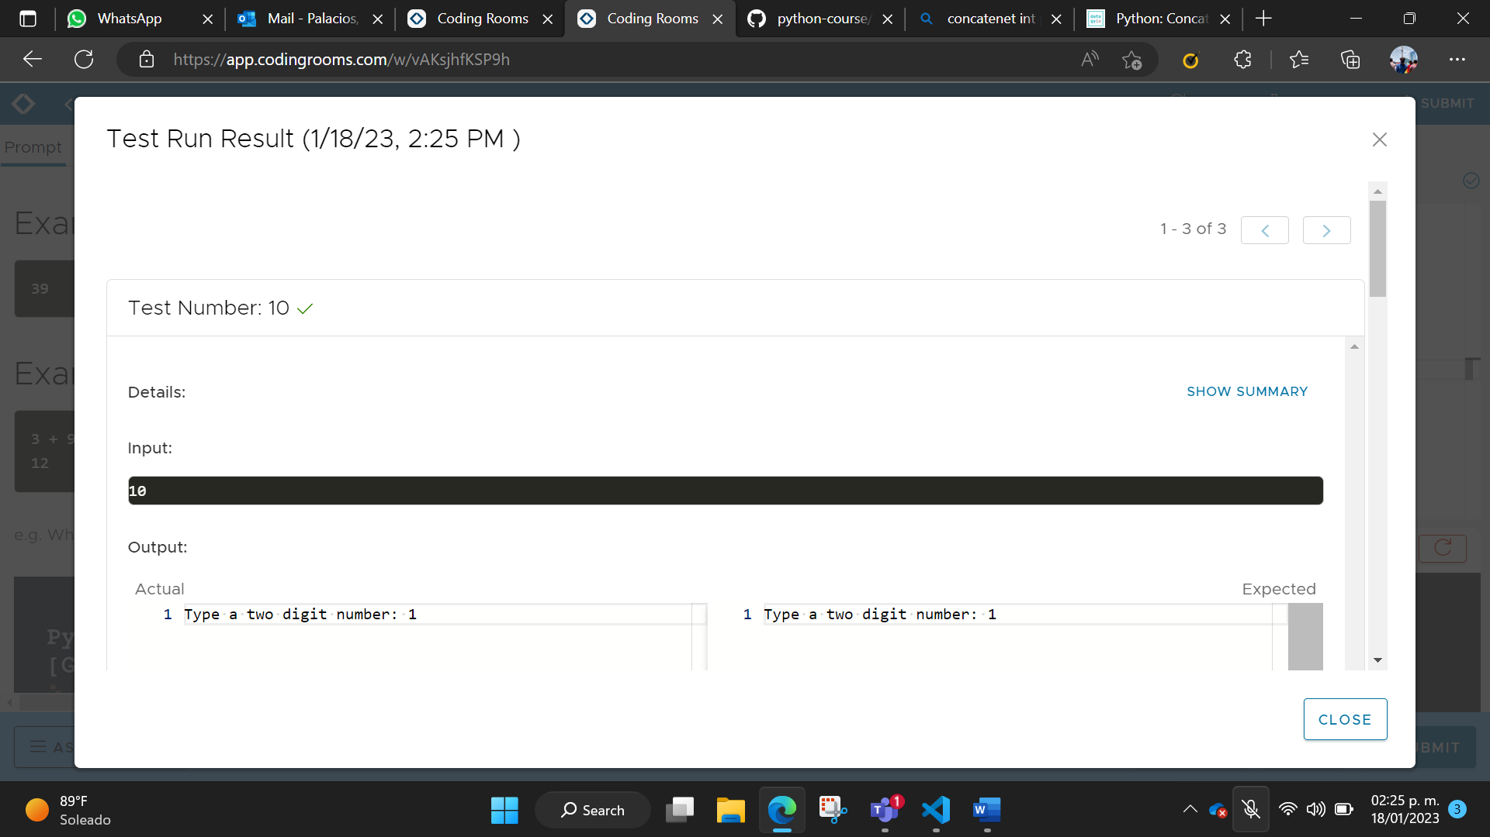

Day 2 Project: Tip Calculator

